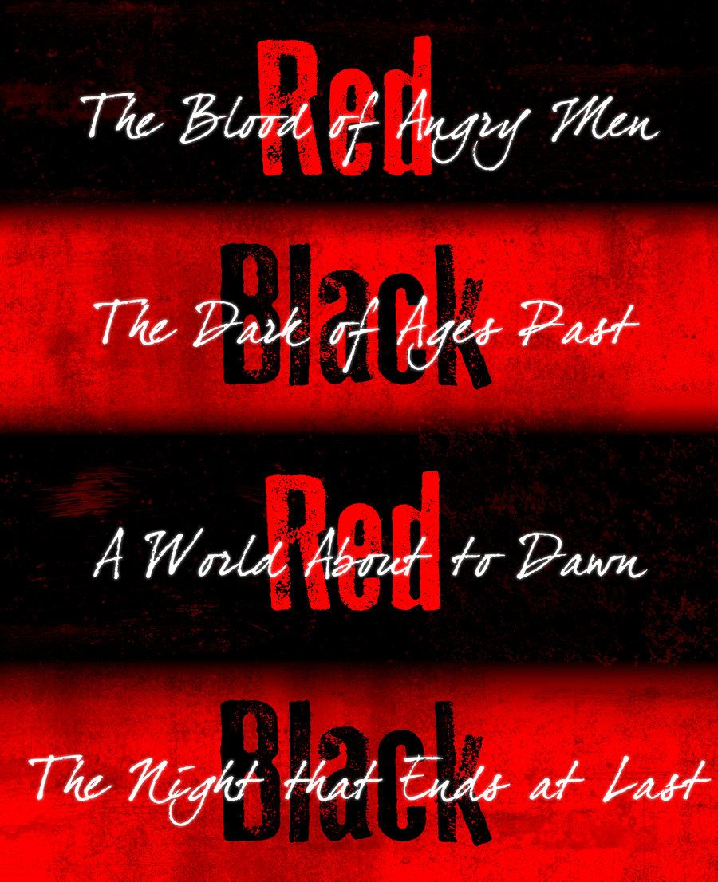

**AUDITION APPLICATION - LES MISERABLES**

Footlight Productions Vic. Peter & Margaret Wills pwills@ncable.net.au 0409 969 648



Attach your photo here

NAME ________________________________________________________________

ADDRESS ____________________________________________________________

_______________________________________ POSTCODE _______

AGE ________

MOBILE ________________________________

EMAIL ___________________________________________________

What is your vocal range? soprano contralto tenor baritone bass

What role/s are you auditioning for? ___________________________________

Please consider this carefully - will you accept a role in the ensemble if unsuccessful in gaining a lead role? yes no

List five recent productions roles you have performed in.

Rehearsals will be held on **Monday** and **Wednesday evenings** and **during the day** on **Sundays**. Please indicate if you have any commitments which would prevent you attending rehearsals. Disclosure of these commitments will not impact on your selection in the production but it enables the production team to plan rehearsals accordingly eg when VCE exams are on.

______________________________________________________________________

______________________________________________________________________

______________________________________________________________________

______________________________________________________________________

______________________________________________________________________

**Production team notes -**

**______________________________________________________________________**

**______________________________________________________________________**

**______________________________________________________________________**

**______________________________________________________________________**

| **YEAR** | **COMPANY** | **PRODUCTION** | **ROLE** |
| --- | --- | --- | --- |
|  |  |  |  |
|  |  |  |  |
|  |  |  |  |
|  |  |  |  |
|  |  |  |  |

*PLEASE NOTE:*

*photos will not be returned*